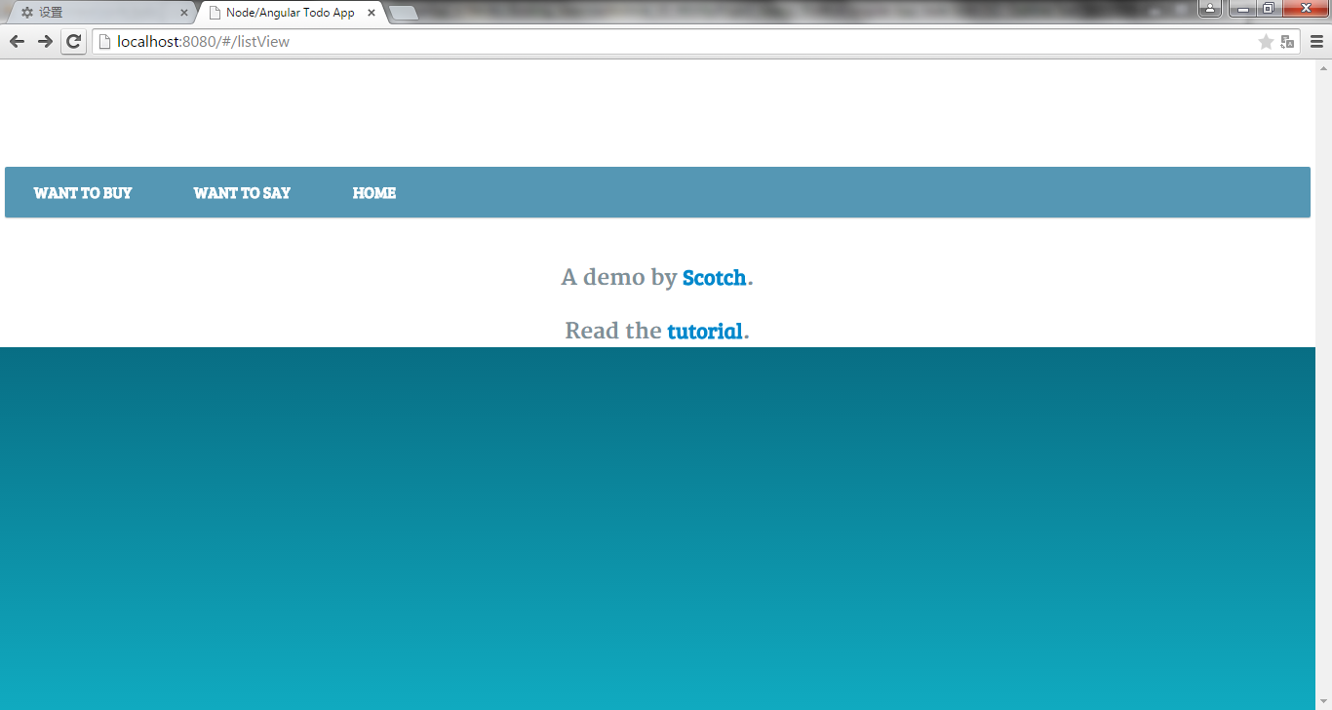

The above error was happening when index.html –include error

The proper picture should be as below:

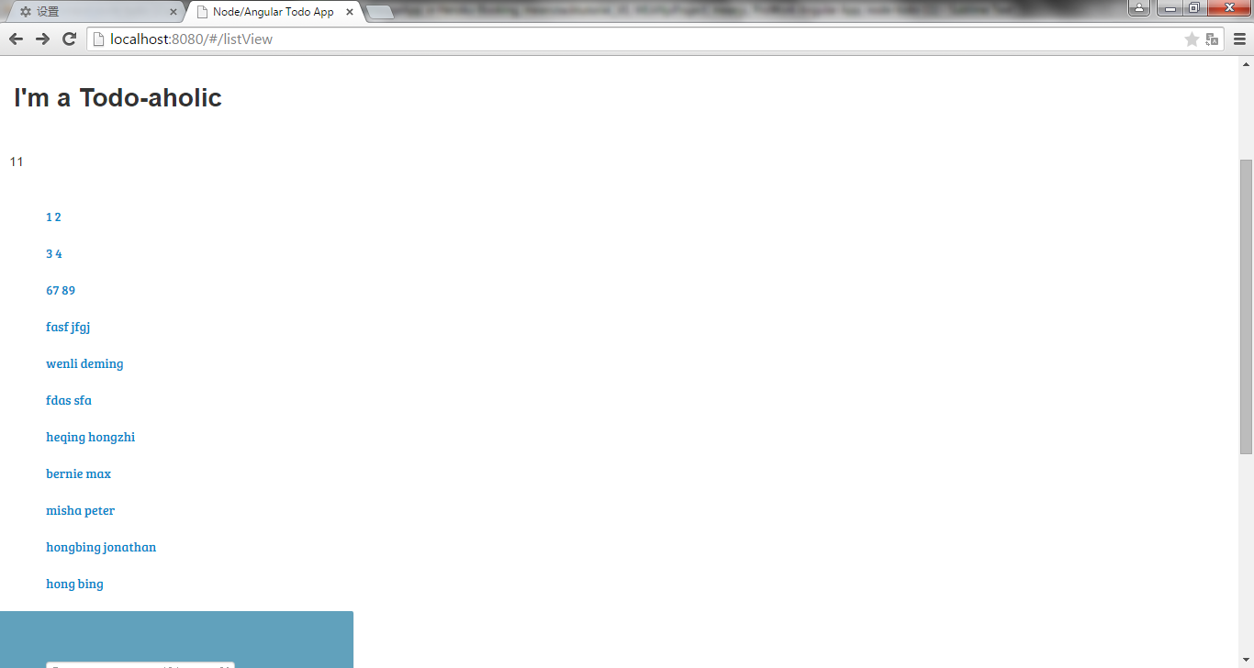

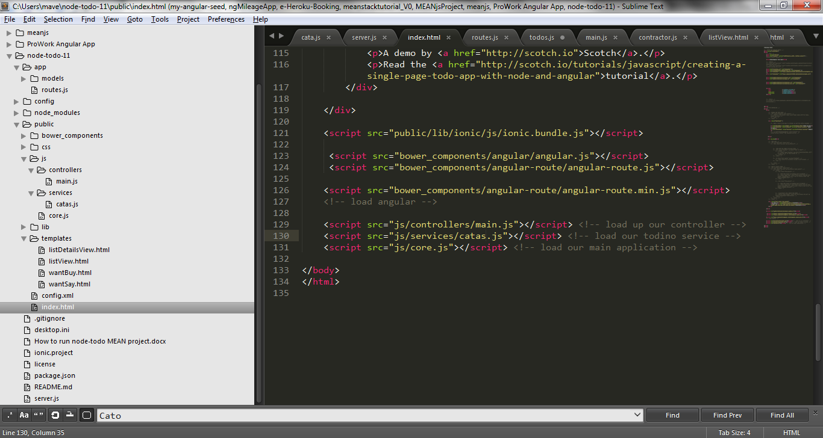

I change the file name of service from todos.js to catas.js, but didn’t change

<script src="js/services/todos.js"></script> <!-- load our todino service -->

Right:

<script src="js/services/todos.js"></script> <!-- load our todino service -->